2025 Washougal Arts Festival 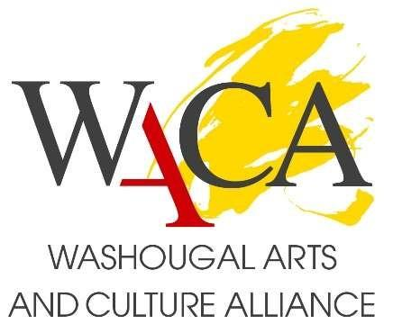

**Saturday, August 9, 2025**

Artist Entry Form

**Entries must be received by Monday, May 12, 2025.**

|  |  |
| --- | --- |
| NAME |  |
| ADDRESS |  |
| PHONE |  |
| EMAIL |  |
| WEBSITE URL |  |
| Facebook & Instagram URL |  |
| ARTIST  STATEMENT  (150 words max) |  |
| Medium |  |
| If accepted, will you need ELECTRICITY at the Festival? | YES  NO |

Submit via email by Monday, May 12, 2025 to WashougalArts@gmail.com:

* this completed entry form
* three pictures of recently completed work (.jpg format)

THANK YOU!

Questions?

Email questions to WashougalArts@gmail.com.